The World is Not Flat:
Current Issues

The economic impacts of COVID-19 on Australia’s international trade and partnerships
Class workbook and literacy activities

Name: ____________________

What is COVID-19?

As you watch the Alan Kohler report, identify some of the key economic impacts both globally and on the Australian economy?

The impacts of a pandemic like this can be seen by various industries and groups of people in our economy including:

Impact on Households

- Consumers under lock down buy toilet paper, pasta, rice, flour, tinned food and anything else they can to avoid shortages in the long term.
- Bringing forward consumption.
- Households forced to stay inside or in self-isolation.
- Many workplaces are encouraging people to work from home.
- Overall, growing concerns, uncertainty and fear.
Impact on Businesses
- Supermarkets seeing a rush in revenue but are low on stock. Suppliers working around the clock to get stock out.
- Spending redirected towards staple necessities means less money spent on wants and luxuries. Retail is missing out!
- Hospitality industries are seeing less people going out to eat.
- Businesses preparing for “shut down periods” and ensuring all staff have what they need to work from home.
- Any supplies being manufactured or shipped from China have been delayed.
Examples: Hyundai

Writing Task 1: How to interpret questions.
Discuss how fear and panic of individuals from the virus, has impacted on businesses (4 marks).
Whenever you see a question there are three things you need to identify:
- What is the directive verb? This is usually the first word in a question which tells you HOW you should be answering the question.
- What are the key words? This will tell you WHAT you are going to write about.
- How many marks is it worth? This will tell you HOW MUCH to write.
Discuss = Identify issues and provide points for and/or against
Positive impacts | Negative impacts

Answer the question below:

Impact on Commodity Markets
- China is ________________________________, and the historic contraction in demand due to the Coronacession adversely affected commodity markets. Following a contraction in 2020 and an expected sharp rebound in 2021, global oil demand growth is set to ____________ as consumption of transport fuels increases.
- Australia’s trade _________ grew to A$8.5bn (US$6.55bn) in March 2021, driven primarily by an ________ in demand for iron ore. However, exports of Australian coal, coke and briquettes fell sharply since China’s unofficial ban began in October.
- With iron ore output in ___________________________ insufficient to meet demand, and alternative sources in Africa years away from viability, China is likely to ____________________________ on Australian output for the foreseeable future.
Impact on Sport
- Many sport matches are being held “behind closed doors” overseas and sporting coordinators in Australia are encouraging people not to attend if they are sick.
- Less people buying tickets to sporting events.
- Olympic Games in Tokyo had no audiences. Postponed until recently.
List some sporting competitions that have been cancelled because of the corona virus:
Impact on Tourism
- On the demand side, the impact on ______________________________ has been significant.
- Inbound international and interstate travel fell ______________. The impact of the decline is dramatic – 7.6 million fewer international arrivals and 45 million fewer domestic overnight trips, resulting in a loss of around ________________ in visitor spend.
- Travel and tourist businesses are experiencing extreme loss of profits.
- Scott Morrison recently banned all travel to ______________________________________________________________.
Article Analysis: ‘It doesn’t cut it’: Tourism sector hits out at Australia’s ‘border roulette’
https://www.smh.com.au/politics/federal/it-doesn-t-cut-it-tourism-sector-hits-out-at-australia-s-border-roulette-20210511-p57r0l.html
The tourism sector says it has been treated like a “second-class citizen” in the federal budget, warning that operators will go under before the government ever reopens the border to international visitors.
The government’s budget predicts the border will reopen mid next year but is based on the assumption that the vaccine rollout will be completed by the end of this year.
The government had previously declined to set out when the border would open or state a goal for when the population would be vaccinated.
The budget papers assume that inbound and outbound international travel will remain low through to mid-2022, after which “a gradual recovery in international tourism is assumed to occur”.
“The continued economic recovery will rely on the effective containment of COVID-19 outbreaks both here and abroad and will be a key factor in the timing of the reopening of international borders, which could weigh on the outlook for the tourism and education sectors,” the budget document warned.
Treasurer Josh Frydenberg told the ABC’s 7.30 that the assumptions were “cautious”.
Margy Osmond, from the Tourism and Transport Forum, said given the delays to the vaccine rollout, the sector needed more certainty from the government on its plan for opening up than the vague outline given in the budget.
“We need to be able to prepare; I’m getting calls from international travel operators asking if we could have some certainty because we’d like to start making bookings.
“But it’s becoming border roulette, everyone in the government’s got a different attitude about when the border will reopen.
“We can’t recover without international borders being open, they need to address certainty and then skills and the level of support for things like attractions, otherwise they’ll go under and there will be nothing left for tourists to come and see and no staff to serve them when the border eventually does reopen.”
The international border closure is also creating a huge skills shortage, as workers who would ordinarily work in the agriculture, hospitality and other low-paying sectors have been shut out.
James Goodwin, from the Australian Airports Association, said the pandemic stimulus measures were masking the broader economic effects of keeping the borders closed.
“We urge the Australian government to work with industry and develop a plan to slowly and safely reopen the borders, starting with more travel bubbles with other COVIDSafe nations, similar to the arrangement we have with New Zealand, which is working well,” he said.
Simon Westaway, Executive Director of the Australian Tourism Industry Council (ATIC), said that the government urgently needed to lift vaccination rates.
“The federal budget outlooks indicate no foreseeable international market recovery for Australia’s visitor economy, and this sadly spells further tourism business and job losses,” he said.
“Low national COVID-19 vaccination rates need to be rapidly lifted ... to enable industry to work constructively with the government on a safe, if staggered, future border re-opening timetable.”
The government had previously given up on setting out a new goal for vaccinating the population for COVID-19 after failing to achieve its target of rolling out 4 million jabs by April.
So far 2.7 million vaccinations have been administered. The government has struggled to secure supplies after ruling out the AstraZeneca vaccine for anyone aged below 50 and dropped its target of delivering a first dose to all adults by October.
Labor’s treasury spokesman Jim Chalmers said the budget was hostage to the vaccine rollout being complete by the end of the year. He had little confidence in the government’s ability to deliver, based on their initial performance.
“No wonder the tourism sector is angry when so much of their business was counting on the Prime Minister delivering here,” he said.
“This budget is hostage to the vaccine rollout and we know how comprehensively the government has already failed in meeting its early goals.
“Scott Morrison needs to do more than just assume the vaccine rollout will be achieved by the end of the year but show how he can guarantee this so the economy can be reopened safely.”
The budget papers show funding for repatriation flights and extra consular assistance for Australians stranded overseas as a result of the border closures. The $119.9 million has been allocated until 2024-2025.
The budget did not allocate funding for new quarantine facilities, despite repeated calls from some of the Labor premiers, the federal opposition and crossbench MPs.
Independent MP Zali Stegall said she was “disappointed” the budget failed to provide any solution to opening the borders sooner.
“Given the situation globally and the pace of the vaccine rollout domestically, it is difficult to see us opening the borders until well into 2022 without a different approach to quarantine,” she said.
“The Morrison government has announced $487 million for quarantine in the Northern Territory but no new facilities nationally.
“This would have been a serious investment in the development of a national federal quarantine system and would have demonstrated a commitment to resuming trade, investment and tourism.”

Activities:
- Highlight 3 key points from the article.
- Circle any words you do not understand. Then look them up and define them.
- List 3 key impacts of the corona virus on employment in the tourism sector.
____________________________________________________________________________________________________________________________________________________________________________________________________________________________________________________________________________________________________________
Writing Task 2: Learning the difference in directive verbs
Assess the impact of the Corona Virus on the tourism sector (4 marks).
Whenever you see a question there are three things you need to identify:
- What is the directive verb?
- What are the key words?
- How many marks is it worth?
Assess = Make a judgement of value, quality, outcomes, results or size
Con’s (disadvantages)

Pro’s (advantages)

Judgement

Answer the question below:

Impact on Education
- Ban on non-resident foreigners entering Australia from China
- Chinese students account for about 0.6% of Australia’s gross domestic product
- Some universities have already delayed the start of term and it is likely to affect their financial standing because of relatively lower international enrolments and exchange programs.
- Chinese students make up about 60% of the international cohort at Australia’s big universities. There revenue and cash reserves will decrease significantly.
- Widespread school closures interrupting education.

Impact on Share Market
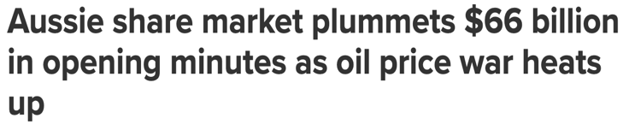
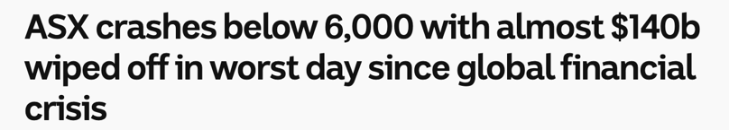
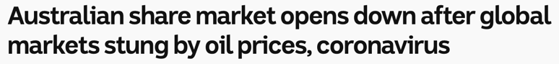

How does a plunge in the share market impact the economy?

