ASSESS THE EFFECTIVENESS OF THE BUDGET ​POLICIES IN ACHIEVING FE IN THE AUS ECO.  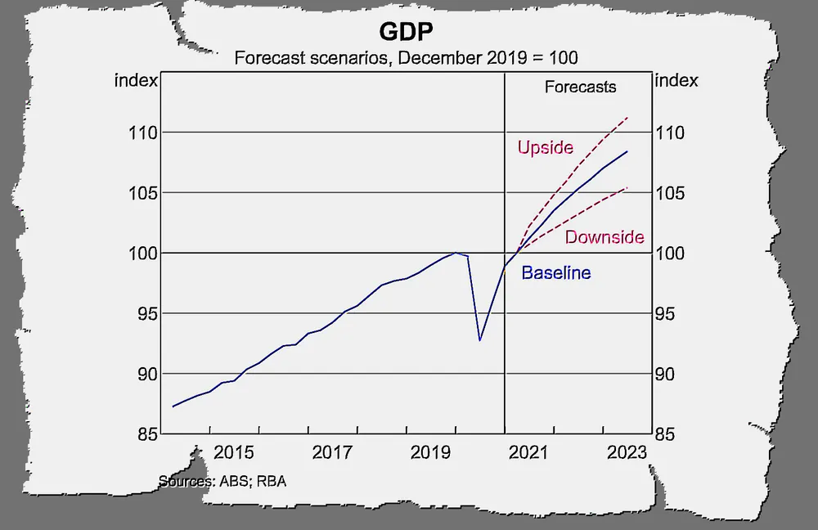  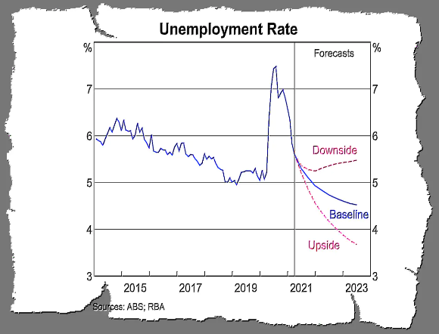  Link  Aus is experiencing weak wage growth, weak business investment and weak productivity improvement. The budget focuses on these issues. Most economists back the decision. Limitations on the effectiveness lie in how long the govt pursues this policy before it switches to repairing the debt. |  | Plan  Name and define.  Full employment + budget & its priorities  Expand (describe)  Government policies must target both cyclical unemployment and NAIRU factors like structural and frictional unemployment.  Explain (analyse)  FE is when wages start growing again. The balance of evidence suggests it is below 5%. Budget focuses on achieving sustained low unemployment.  Explain (significance)  Budget uses more fiscal stimulus to target a much lower rate of unemployment, growth in wages, stronger growth in consumer spending stronger business investment spending break out of the “slow-growth trap”.  Evidence  Budget priority: “Creating jobs and rebuilding our economy” $7.8 billion in tax cuts for low- and middle-income earners; $15.2 billion over ten years to fund infrastructure commitments; new apprenticeships and training places.
 | DETAILED PLAN
Intro | Overview of full employment  Overview of budget priorities to reach full employment.  Define FE, NAIRU, estimates and current unemployment statistics.  Current economic conditions  Fiscal policy and current budget priorities.
Para 1
Para 2
Para 3
Para 4 Mechanisms in the budget that could move Aus eco to FE
Con Evaluation
LOOK FURTHER:
https://theconversation.com/exclusive-top-economists-back-budget-push-for-an-unemployment-rate-beginning-with-4-159989
http://www.rossgittins.com/2021/05/budget-shock-morrison-hit-over-head-by.html

